 LOGIC TECH LABS | PRODUCT DATA SHEET | PAGE 1 OF 3
LTL-IND-403 SERIES
Shielded Low-DCR Power Inductors
Ultraminiature surface-mount inductors for compact power conversion and filtering
PRODUCT OVERVIEW  The LTL-IND-403 Series combines magnetic shielding, compact construction, and low DC resistance in a tape-and-reel package. The family spans 1.0 µH to 10,000 µH and supports rated current up to 3.0 A. | 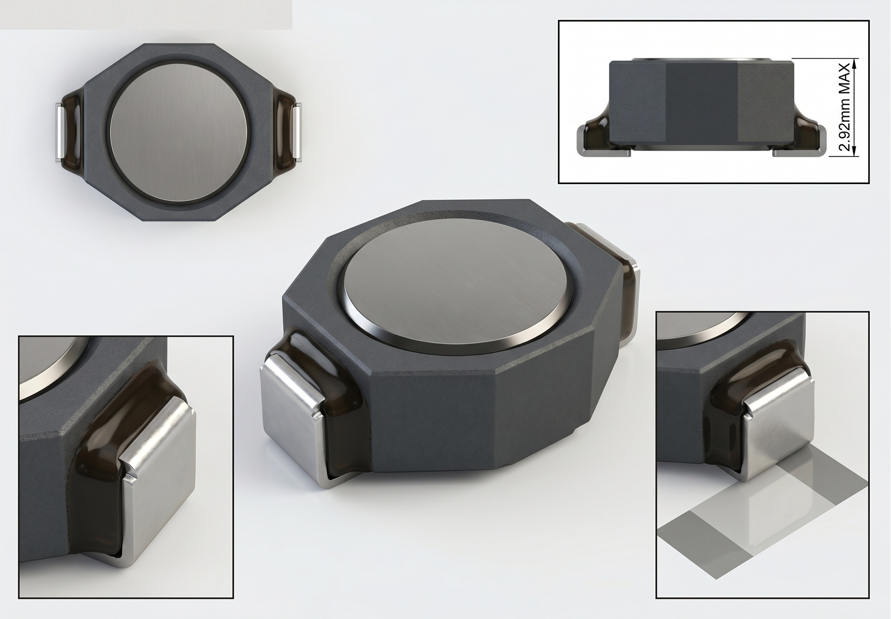
KEY SPECIFICATIONS
1.0 to 10,000 µH  Inductance range | Up to 3.0 A  Rated current | -40°C to +85°C  Operating range | 6.86 x 4.45 mm  Maximum footprint

Features
- Magnetically shielded construction for reduced stray field coupling.
- Low DC resistance supports high conversion efficiency and reduced power loss.
- Compact package suited to space-constrained and battery-powered products.
- Broad inductance selection from 1.0 µH through 10 mH.
- Rated current options from 0.02 A through 3.0 A.
- Supplied in tape-and-reel packaging for automated assembly.

Typical Applications
- DC/DC converter energy storage
- Power-supply filtering and decoupling
- Portable and handheld equipment
- Communications and industrial electronics

Ordering Information
Field | Format | Meaning
Series | LTL-IND-403 | Shielded inductor family and 403 package class
Inductance code | 1R0 ... 103 | R is the decimal point; first two digits plus multiplier for µH values
Example: LTL-IND-403-100 = 10 µH, ±20% inductance tolerance.
Product enquiries: logic-tech-labs.com | logic.tech.labs@gmail.com

LOGIC TECH LABS | PRODUCT DATA SHEET | PAGE 2 OF 3
ELECTRICAL CHARACTERISTICS
Specifications at 25°C
Inductance tolerance: ±20%. Values are maximum or typical as indicated.
LTL Part Number | Mark | L (µH) | Q min. | DCR max. (Ω) | SRF typ. (MHz) | Rated I max. (A)
LTL-IND-403-1R0 | 1R0 | 1.0 | 30 @ 200 kHz | 0.040 | 250 | 3.0
LTL-IND-403-1R5 | 1R5 | 1.5 | 30 @ 200 kHz | 0.045 | 125 | 2.8
LTL-IND-403-2R2 | 2R2 | 2.2 | 40 @ 200 kHz | 0.050 | 120 | 1.8
LTL-IND-403-3R3 | 3R3 | 3.3 | 40 @ 200 kHz | 0.055 | 120 | 1.6
LTL-IND-403-4R7 | 4R7 | 4.7 | 40 @ 200 kHz | 0.060 | 105 | 1.4
LTL-IND-403-6R8 | 6R8 | 6.8 | 40 @ 200 kHz | 0.065 | 50 | 1.2
LTL-IND-403-100 | 100 | 10 | 40 @ 200 kHz | 0.075 | 38 | 1.0
LTL-IND-403-150 | 150 | 15 | 40 @ 100 kHz | 0.090 | 33 | 0.80
LTL-IND-403-220 | 220 | 22 | 40 @ 100 kHz | 0.11 | 25 | 0.70
LTL-IND-403-330 | 330 | 33 | 40 @ 100 kHz | 0.19 | 20 | 0.60
LTL-IND-403-470 | 470 | 47 | 40 @ 100 kHz | 0.23 | 20 | 0.50
LTL-IND-403-680 | 680 | 68 | 40 @ 100 kHz | 0.29 | 15 | 0.40
LTL-IND-403-101 | 101 | 100 | 40 @ 100 kHz | 0.48 | 10 | 0.30
LTL-IND-403-151 | 151 | 150 | 40 @ 100 kHz | 0.59 | 9 | 0.26
LTL-IND-403-221 | 221 | 220 | 40 @ 100 kHz | 0.77 | 6 | 0.22
LTL-IND-403-331 | 331 | 330 | 40 @ 100 kHz | 1.4 | 5 | 0.20
LTL-IND-403-471 | 471 | 470 | 40 @ 100 kHz | 1.8 | 4 | 0.19
LTL-IND-403-681 | 681 | 680 | 40 @ 100 kHz | 2.2 | 3 | 0.18
LTL-IND-403-102 | 102 | 1000 | 50 @ 100 kHz | 3.4 | 2 | 0.15
LTL-IND-403-152 | 152 | 1500 | 50 @ 100 kHz | 4.2 | 2 | 0.12
LTL-IND-403-222 | 222 | 2200 | 50 @ 100 kHz | 8.5 | 2 | 0.10
LTL-IND-403-332 | 332 | 3300 | 50 @ 100 kHz | 11.0 | 1 | 0.08
LTL-IND-403-472 | 472 | 4700 | 50 @ 100 kHz | 13.9 | 1 | 0.06
LTL-IND-403-682 | 682 | 6800 | 50 @ 100 kHz | 25.0 | 1 | 0.04
LTL-IND-403-103 | 103 | 10000 | 50 @ 100 kHz | 32.8 | 0.8 | 0.02
Test condition 1: Inductance measured at 100 kHz, 0.1 V, series equivalent circuit (Ls).
Test condition 2: Rated current corresponds to a typical 30°C temperature rise.
Definitions: DCR = DC resistance; SRF = self-resonant frequency; Q = quality factor.

LOGIC TECH LABS | PRODUCT DATA SHEET | PAGE 3 OF 3
MECHANICAL INFORMATION
Dimensions and Packaging
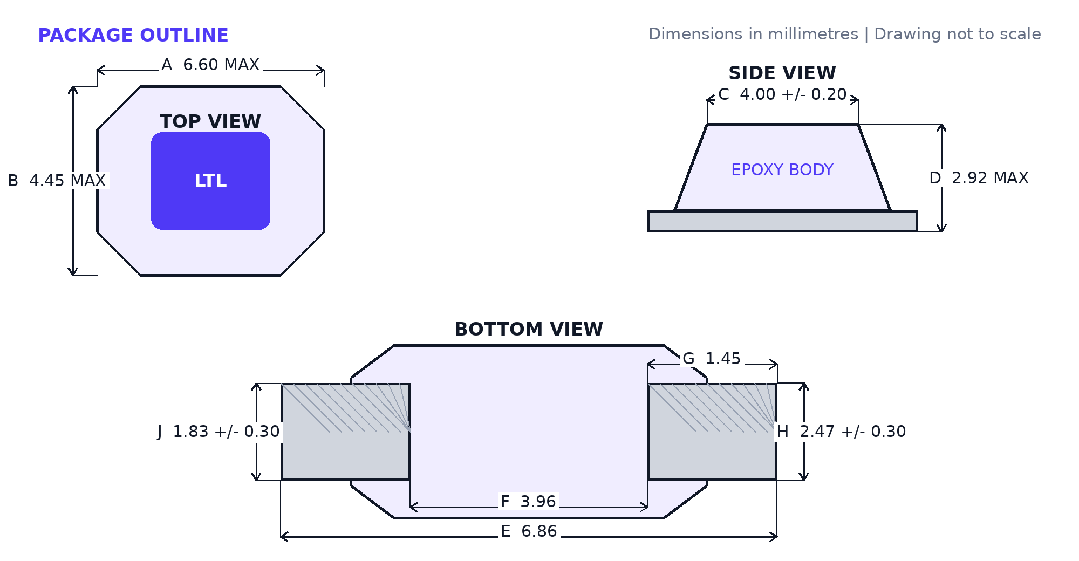

Dimension Reference
Symbol | Dimension | Value (mm) | Limit
A | Top-view length | 6.60 | Maximum
B | Overall width | 4.45 | Maximum
C | Epoxy body length | 4.00 ± 0.20 | Nominal ± tolerance
D | Overall height | 2.92 | Maximum
E | Overall terminal-to-terminal length | 6.86 | Nominal
F | Bottom body length | 3.96 | Nominal
G | Termination length | 1.45 | Nominal
H | Termination/body width | 2.47 ± 0.30 | Nominal ± tolerance
J | Terminal contact width | 1.83 ± 0.30 | Nominal ± tolerance

Packaging and Handling
Standard supply format: tape and reel. Store and handle in accordance with the assembly process requirements for surface-mount magnetic components. Contact Logic Tech Labs for reel quantity, packaging dimensions, soldering guidance, and current material declarations.

Operating Conditions
Parameter | Specification
Operating temperature | -40°C to +85°C
Mounting style | Surface mount

Important Notice
Specifications are subject to change without notice. Designers are responsible for validating suitability under actual electrical, thermal, mechanical, and environmental conditions. Contact Logic Tech Labs before using this product in safety-critical, life-support, or otherwise high-reliability applications.

